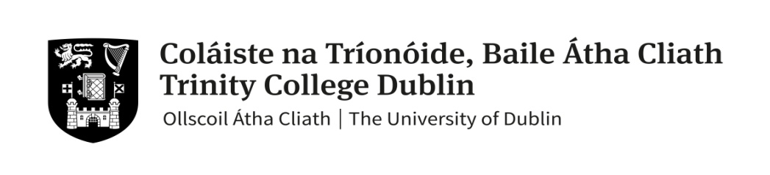

**FACULTY OF ARTS, HUMANITIES & SOCIAL SCIENCES**

**Trinity Business School**

### MSc Business Analytics Semester 2

**Annual Examination 2022-23**

### 

# BU7148 Operations Analytics

**Shivam Gupta** **(External Examiner)**

# Dr. Konstantinos Stouras (Lecturer)

**Time Allowed: 2 hours**

**Instructions for Candidates**

* Enter your Student ID on the next page.
* Please answer all questions include all your answers in this Answer Sheet.
* Submit your file by uploading it back to BlackBoard before the deadline.
* Best of luck!

**Student ID**: 22326199

**I. Business Intuition** (50 marks in total)

**Answer to (Q1)**:

The bottleneck is the process of the system where the workflow is hindered, causing delays, inefficiencies and where the production is more reduced, this means that if we want to obtain the optimal production this process must have a maximum utilization.

If we want to increase the output of our global work system, the improvements have to be made exactly at that point, since the rest of the processes, since they require less time, will not reduce their production, although their utilization will increase.

For example, in the hypothetical case that the production of a car consists of 3 steps, the cutting of the material, the assembly of parts and painting the car. If it takes 10 minutes to cut the parts, 1 hour to assemble them and 20 minutes to paint them, the first car will be ready in 1 hour and a half (total process time), but after that each car will take 1 hour, which is exactly the time it takes the bottleneck to perform its process. If we improve this process thanks to new technology or by increasing the staff, the time to build a car would be reduced, thus increasing the overall efficiency of the whole process.

**Answer to (Q2)**:

In this case, Yuppy will have lower expected sales, since these are the difference between µ, which is the mean of the distribution that follows the demand and the expected lost sales.

As the variance (standard deviation) increases due to the fact that he is younger in the market and therefore the information about the market is less, the expected lost sales increase (assuming that all other factors affecting the critical ratio are equal, price, cost, residual value, etc...).

Therefore, we can safely say, referring to what we discussed in class, that "variability is evil", since it increases uncertainty and will reduce our expected sales.

The formulas that have been mentioned and that we discussed in the class exercises that show this to be true are the following:

**Answer to (Q3a)**:

Relationships that last over time are better in general than relationships that are maintained in short-term markets, because for example, trust is generated, so it is more certain that the conditions with which the market is analyzed remain constant, also the system in general becomes more efficient because some dependence is generated and begins to seek the common good over the individual good and as we have mentioned in class numerous times, in systems, when the common good is prioritized the efficiency of that system increases.

All this also reduces variance (which ALWAYS) is a good thing since "variability is evil".

As a point in favor of short-term relationships, as was also mentioned in class, we can say that it increases the flexibility with which we operate since we are not subject to a single supplier or customer and that opens the possibility of seeking new opportunities in the market.

**Answer to (Q3b)**:

Walmart is a large warehouse with enormous resources and bargaining power, so it is certainly able to match supply to demand and determine prices without the help of a middleman. In addition, Walmart has the ability to immediately build and maintain trust with suppliers.

On the other hand, as discussed in class, one advantage of middlemen is their ability to organize and manage complicated supply networks. For Walmart, buying apparel in China involves negotiating with multiple suppliers, managing diverse manufacturing schedules, and ensuring quality control at multiple facilities. Li & Fung has ties to a network of Chinese companies and can provide logistical assistance in managing supply chain challenges. This coordination and control advantage may be one of the main reasons Walmart buys apparel from Li & Fung.

**Answer to (Q4)**:

G

**Answer to (Q5)**:

A

**Answer to (Q6)**:

E

**Answer to (Q7)**:

The data they have in TeaCiDee is wrong or outdated, because even if all students graduating each year were all 3 years would be an average of 93 students, but we can see that every year this number is higher except for the year in which there are 92.

**II. Quantitative Questions** (50 marks in total)

**(Q8) Sounds Ops to me** (26 marks in total)

**Answer to (Q8a)**:

Taking into account these process data, the maximum output rate will be 9.6 trays/hour, which is the capacity of the last process, the bottleneck.

We used the formula: Capacity =

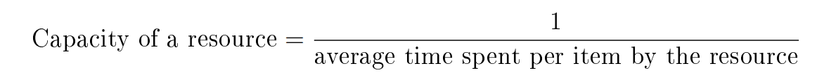

**Answer to (Q8b)**:

If this capacity were to be reached, all processes below this capacity would have to be upgraded, since only one process below would slow down the overall process. The processes below this capacity are the second, third and fourth, with a capacity of 10, 10.3 and 9.6 trays/hour.

**Answer to (Q8c)**:

**(Q9) Lazy Profs** (24 marks in total)

**Answer to (Q9a)**:

An arrival is when one of the faculty members orders the book and a makes a request.

The servers are the mail service and the assistant.

**Answer to (Q9b)**:

A departure happens when a customer is leaving the system so that another customer can use the same service. Break in this scenario occurs when the faculty assistant returns the book to the library so it may be rented again.

**Answer to (Q9c)**:

**Answer to (Q9d)**:

**~ End ~**